Problem No: 01

Problem Statement: Write a MATLAB function for Manchester Encoding, include both IEEE and JE Thomas.

Codes:
% Line coding main function
clear all;
close all;

bits =[1 0 1 0 0 1 1 1 0 0 1 ];

bitrate = 1;

figure; % show the figure
[t,s] = manchester(bits,bitrate,"JE_THOMAS");
plot(t,s,"lineWidth",3);
xlabel("Time in Sec","fontsize",14,'fontWeight','bold');
ylabel("Amplitude in Volts",'fontsize',14,'fontWeight','bold');
title(['Manchester JE Thomas: ' num2str(bits)]);

figure; % show the figure
[t,s] = manchester(bits,bitrate,"IEEE");
plot(t,s,"lineWidth",3);
xlabel("Time in Sec","fontsize",14,'fontWeight','bold');
ylabel("Amplitude in Volts",'fontsize',14,'fontWeight','bold');
title(['Manchester IEEE: ' num2str(bits)]);

function [t, x] = manchester(bits, bitrate, convention)
% MANCHESTER Generates a Manchester encoded signal
% bits - Input binary sequence
% bitrate - Transmission bitrate
% convention - Encoding convention ('IEEE' or 'JE_THOMAS')
% t - Time vector
% x - Encoded signal

T = length(bits) / bitrate; % Total duration
n = 30; % Number of samples per half bit
N = n * length(bits) * 2; % Total number of samples

dt = T / N;
t = 0:dt:T;
x = zeros(1, length(t));

for i = 0:length(bits)-1
start_idx = i * 2 * n + 1;
mid_idx = start_idx + n;
end_idx = (i + 1) * 2 * n;

if strcmp(convention, 'IEEE')
if bits(i+1) == 0
x(start_idx:mid_idx) = -1; % First half low
x(mid_idx+1:end_idx) = 1; % Second half high
else
x(start_idx:mid_idx) = 1; % First half high
x(mid_idx+1:end_idx) = -1; % Second half low
end
elseif strcmp(convention, 'JE_THOMAS')
if bits(i+1) == 0
x(start_idx:mid_idx) = 1; % First half high
x(mid_idx+1:end_idx) = -1; % Second half low
else
x(start_idx:mid_idx) = -1; % First half low
x(mid_idx+1:end_idx) = 1; % Second half high
end
else
error('Invalid convention. Choose either "IEEE" or "JE_THOMAS".');
end
end
end

Output:

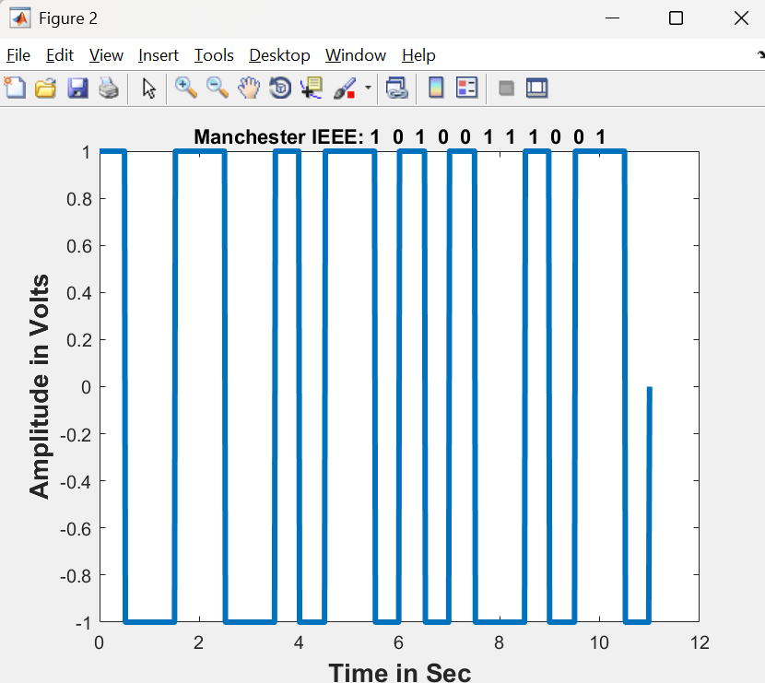
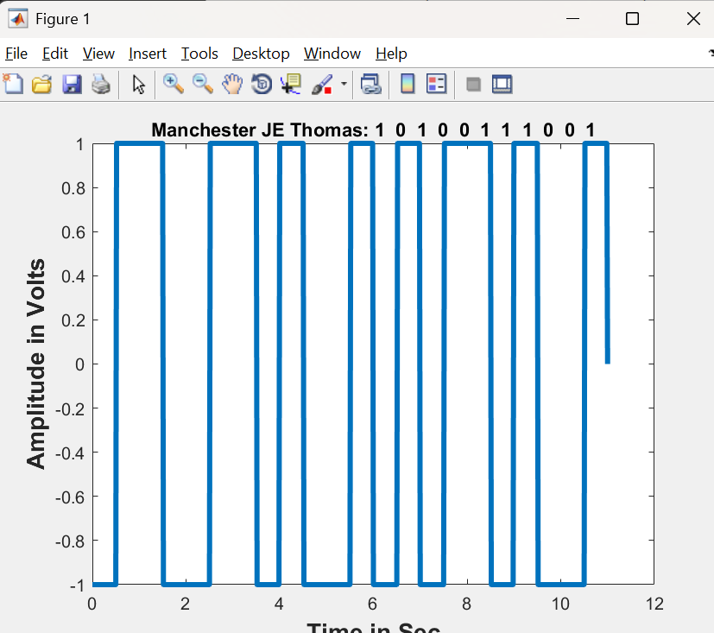

Problem No: 02

Problem Statement: Write a MATLAB function for Alternate Mark Inversion

Codes:

% Line coding main function
clear all;
close all;

bits =[1 0 1 0 0 1 1 1 0 0 1 ];

bitrate = 1;

figure; % show the figure
[t,s] = ami(bits,bitrate);
plot(t,s,"lineWidth",3);
xlabel("Time in Sec","fontsize",14,'fontWeight','bold');
ylabel("Amplitude in Volts",'fontsize',14,'fontWeight','bold');
title(['AMI: ' num2str(bits)]);

function [t, x] = ami(bits, bitrate)
% AMI Generates an Alternate Mark Inversion (AMI) encoded signal
% bits - Input binary sequence
% bitrate - Transmission bitrate
% t - Time vector
% x - Encoded signal

T = length(bits) / bitrate; % Total duration
n = 30; % Number of samples per bit
N = n * length(bits); % Total number of samples

dt = T / N;
t = 0:dt:T;
x = zeros(1, length(t));

last_one_polarity = 1; % Start with positive for the first '1'

for i = 0:length(bits)-1
start_idx = i * n + 1;
end_idx = (i + 1) * n;

if bits(i+1) == 1
x(start_idx:end_idx) = last_one_polarity;
last_one_polarity = -last_one_polarity; % Toggle polarity
else
x(start_idx:end_idx) = 0; % Zero remains at zero level
end
end
end

Output:

